AWS – SNS(Simple notification services):

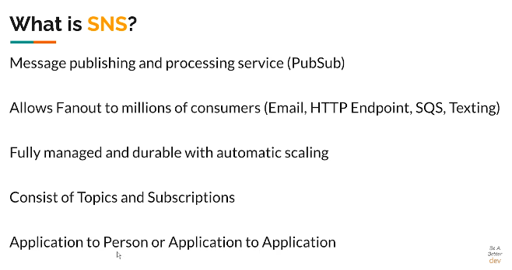s

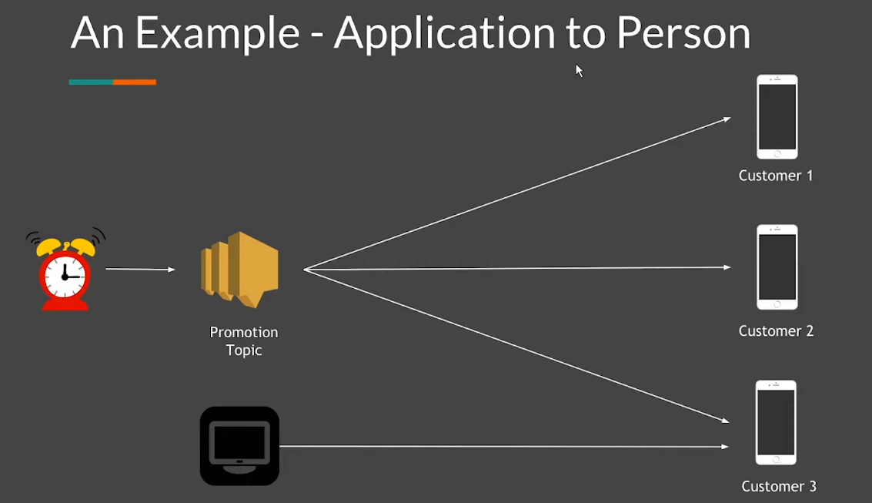d

Topic creation:

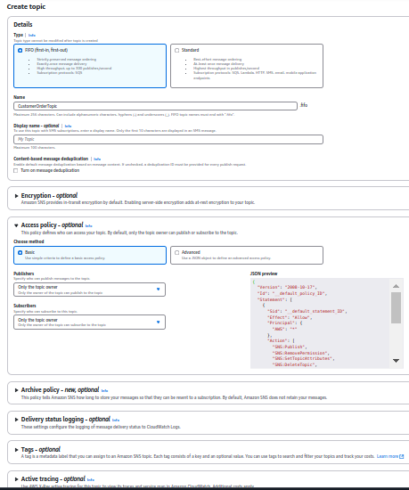

**Then create the subscription:**

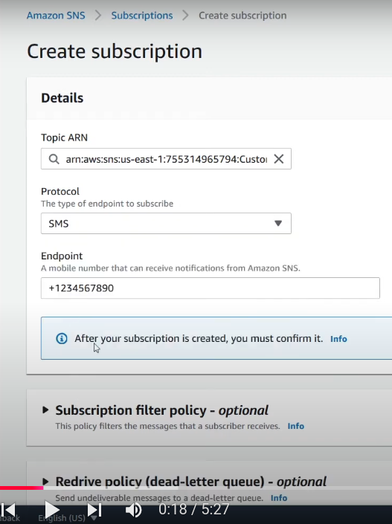

l

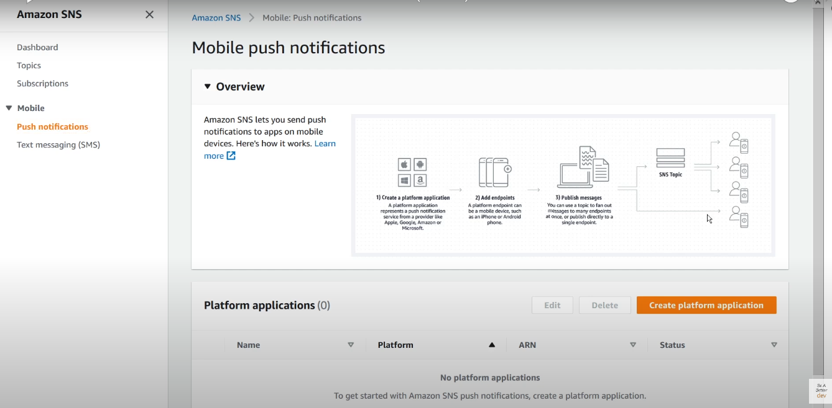l

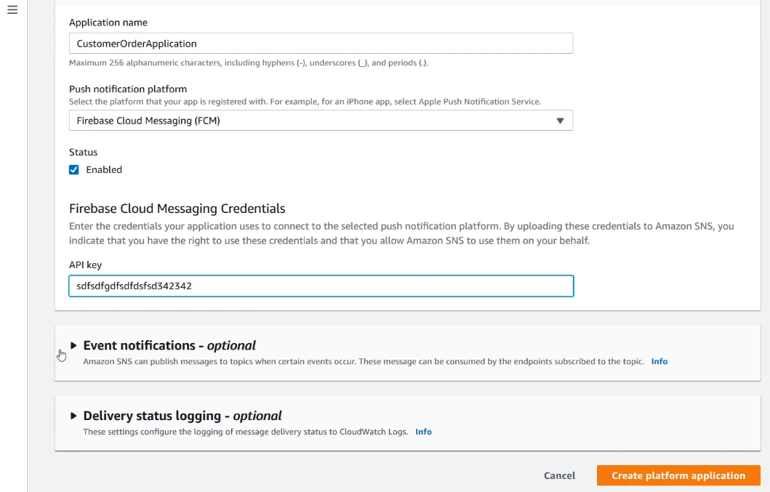v  
  
EventBridge:

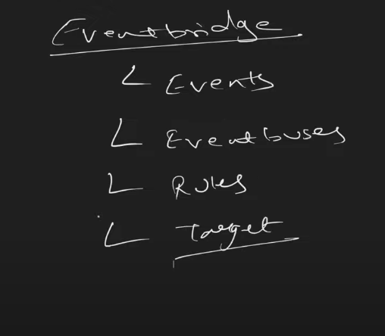

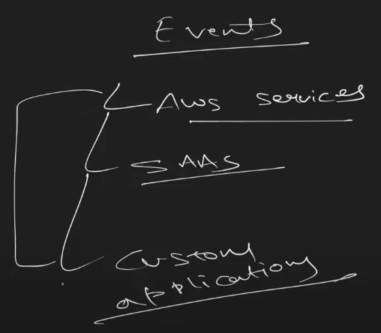

For an example:

Event of AWS services: Like event of creation of EC2 machine and then that event can be used further. Any aws services can produce event

SAAS(software as a services) : salesforce etc.

custom applications.

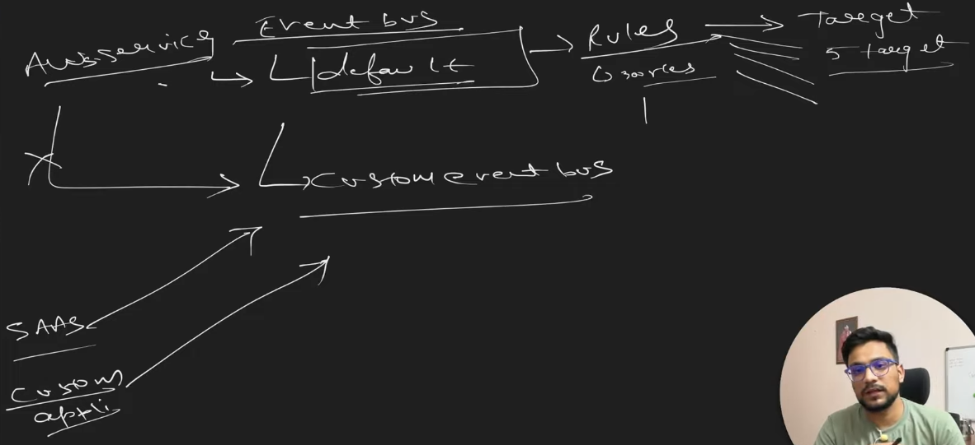

Let’s do, 1 scenerio:

As an when any EC2 machine gets terminated, an SNS topic gets triggered and we can get to know that which EC2 machine got terminated.

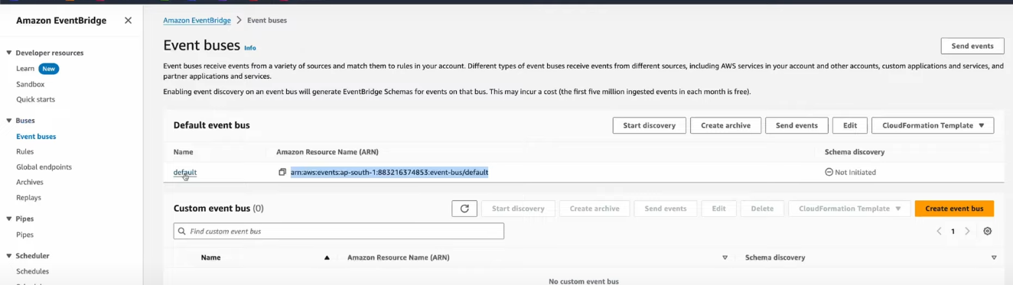

**Now create rule:**

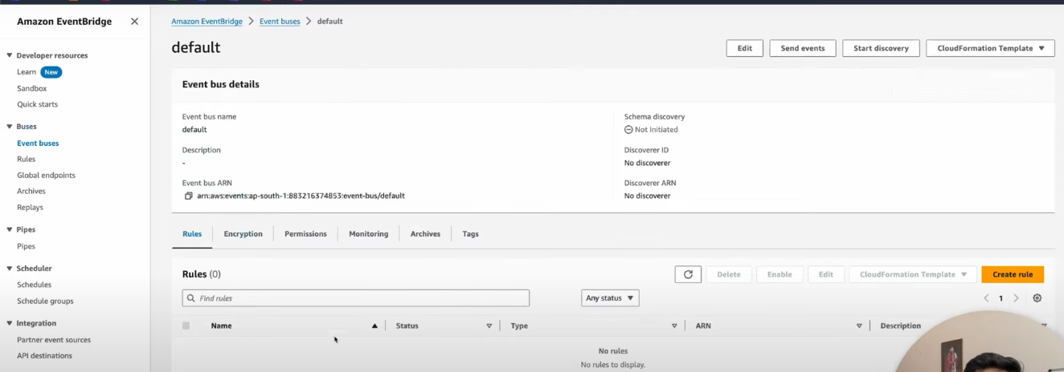j

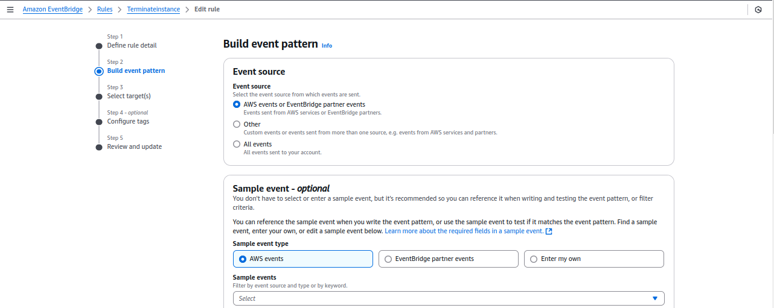

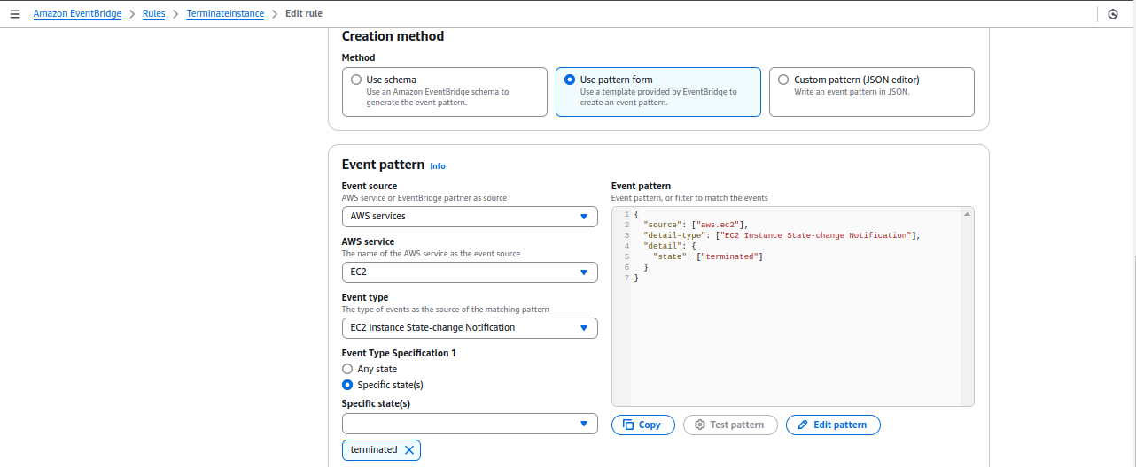

as mentioned below targets, we can create max 5 targets.

Now pass the SNS topic name below: CustomerOrderTopic

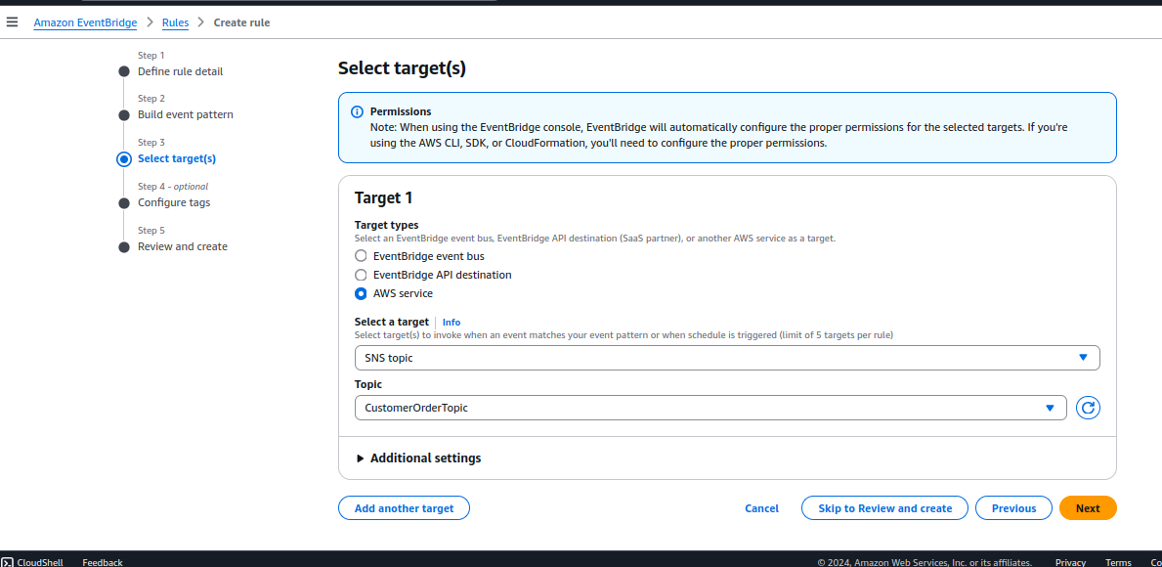

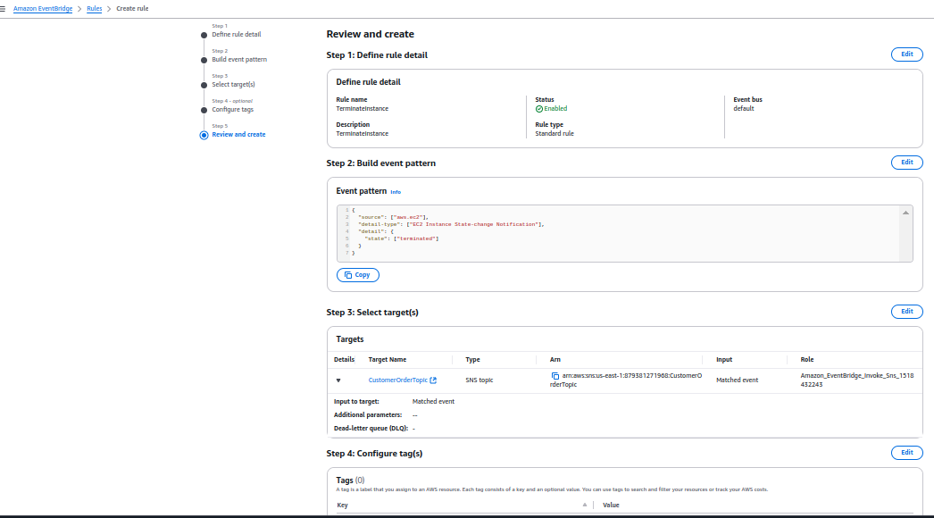

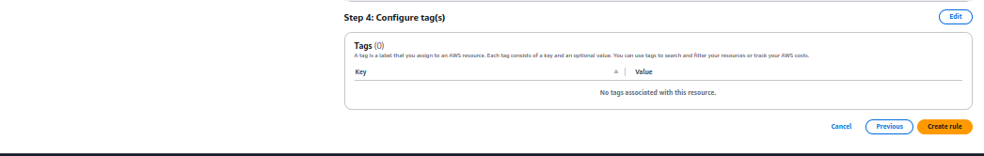A

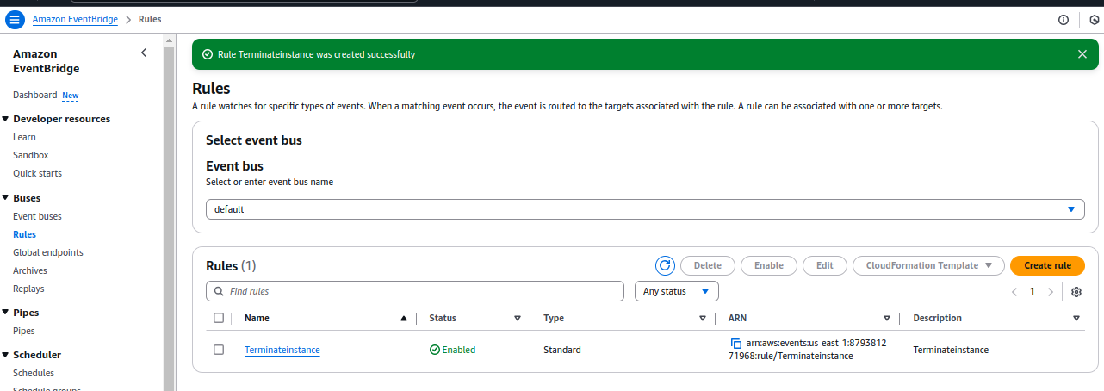s4